**Supplementary Material for HYDRAFloods Module 2**

Generating a Google Earth Engine Authorization Token

SERVIR Science Coordination Office

Curriculum Development Team

Micky Maganini

Contact: [mrm0065@uah.edu](mailto:mrm0065@uah.edu)

Prepared for “Observing and Modelling Surface Water in a Changing World” at ITC

Quartile 3 2022-2023



**Step 1: Run the cell that says ee.Authenticate()**

**Step 2: Click the blue link as shown in the image below**

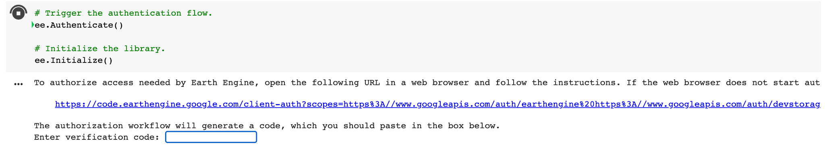

**Step 3: Select the google account (the same google account you are using with Google Earth Engine), then select “Continue”.**



**Step 4: Click the “Choose Project” Text as shown below**



**Step 5: Select the “hydrafloods-for-itc” project as shown below**

1. **Click the circle next to “Select an existing Cloud Project”**
2. **Click “Select a Cloud Project”**
3. **Type in “hydrafloods”**
4. **Click on “hydrafloods-for-itc”**
5. **Click the blue “Select” button towards the bottom right of the popup panel**

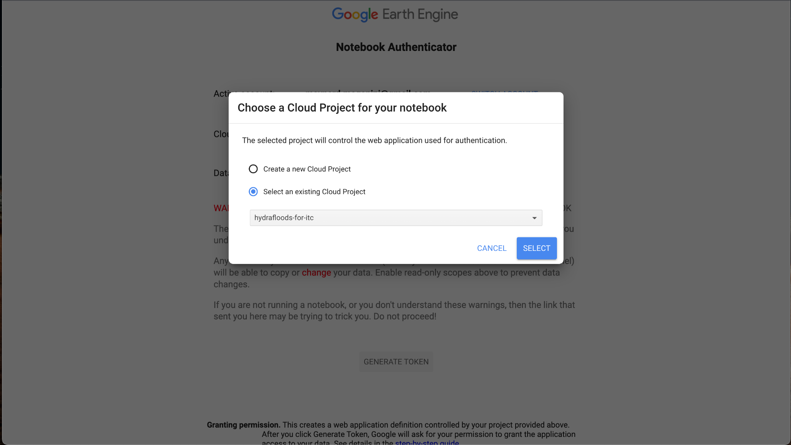

**4/1AWtgzh7ypP1kt4RsNpgF5hTTmD0MCajKMeb9etfrA7gUiIM2TVTWH8c4SFM**

**Step 6: Click the blue “Generate Token” button shown by the black arrow in the image below.**



**Step 7: Click the Google Account that you have registered in Google Earth Engine, as shown by the red arrow in the image below.**



**Step 8: Click the blue continue button, as shown by the red arrow below.**



**Step 9: Click the two boxes shown by the red arrows in the image below. They will now appear with check marks inside them as shown by the image. Then click the “Continue” button shown by the blue arrow in the image below.**



**Step 10: Copy the Authorization Code by clicking the button indicated by the red arrow in the image below.**



**Step 11: Paste the authorization code (using Command + V on Mac or Ctrl + V on PC) into the code cell we ran in step 1. IMPORTANT: Click Shift + Enter to run the cell and complete the authorization process. The code cell will now say “successfully saved authorization token” as shown in the image below.**

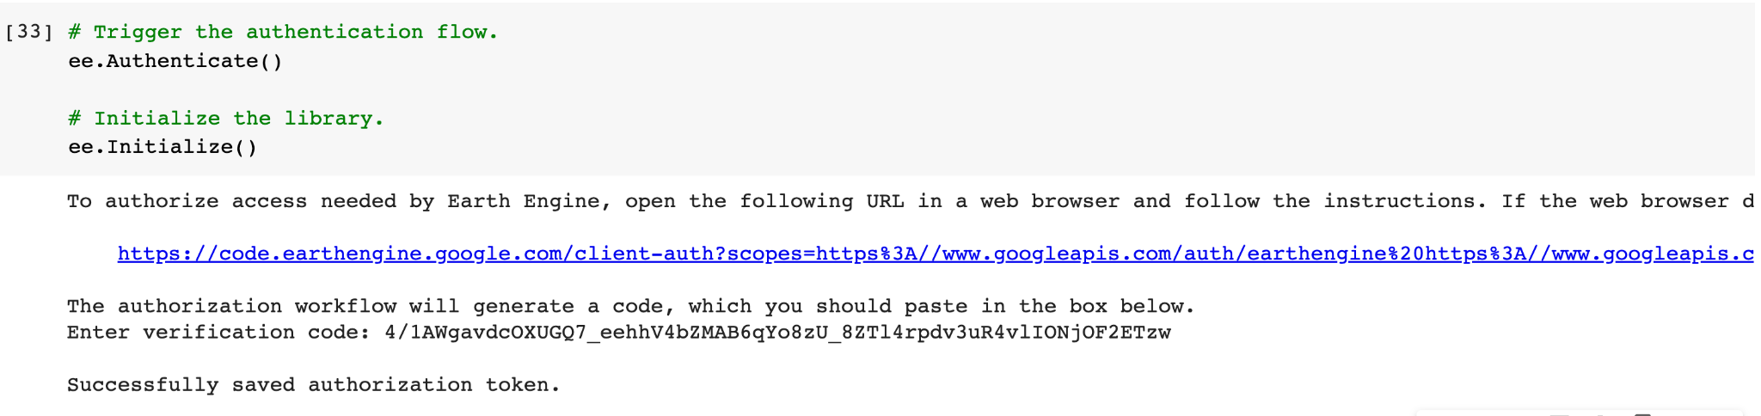

**Congrats! You have successfully authenticated Earth Engine. You may return to your Google Colab notebook!**